EXPERIMENT 1 :FLIGHT RESERVATION SYSTEM
AIM
To create a simple cloud-based Flight Reservation System using Zoho Creator as a Cloud Service Provider and demonstrate Software as a Service (SaaS) by developing a form to collect and manage flight reservation details such as passenger name, phone number, email, trip type, departure, destination, departure date, return date, fare type, and class.

SOFTWARE REQUIRED
Zoho Creator – Cloud-based application development platform

PROCEDURE
1. Open Zoho Creator in a web browser and sign in.
2. Create a new application named Flight Reservation System.
3. Create a new form named Flight Reservation.
4. Add the required fields such as Passenger Name, Phone Number, Email, Trip Type, From, To, Departure Date, Return Date, Passenger Type, Class, Fare Type, Flight Type, and Number of Passengers.
5. Configure the dropdown fields with the required choices.
6. Save the form and create the All Flight Reservations report.
7. Enter sample passenger and flight details in the reservation form.
8. Click Submit to store the reservation details in the cloud.
9. Open the report and verify that the submitted reservation is displayed.
10. Thus, the Flight Reservation System is created and demonstrated as a SaaS application using Zoho Creator.

SAMPLE INPUT
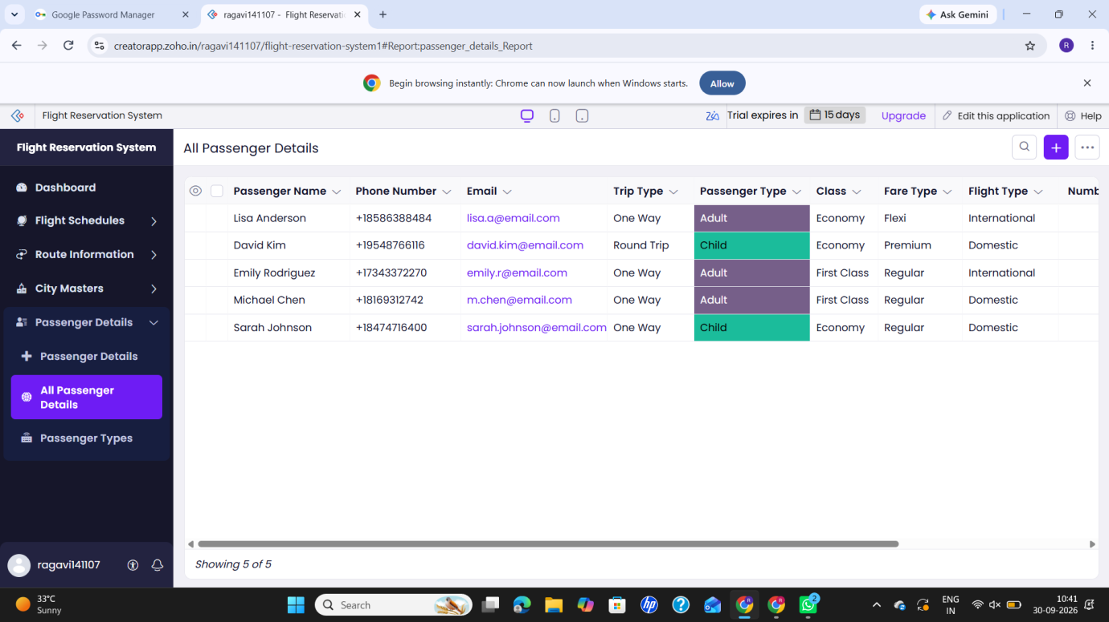

EXPECTED OUTPUT
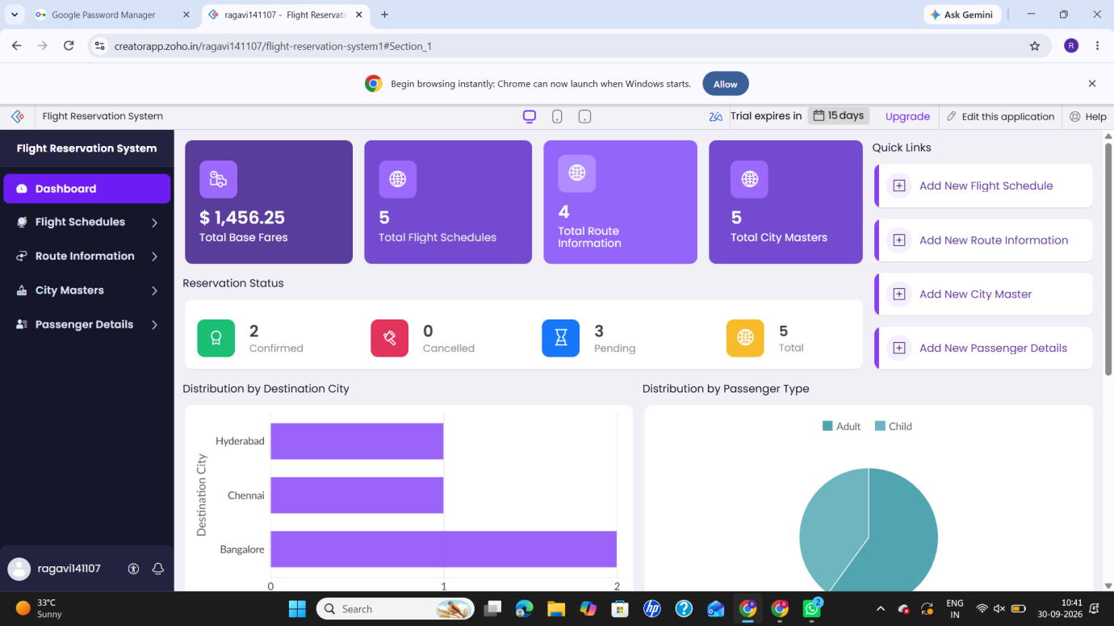

RESULT
Thus, the Flight Reservation System was successfully created using Zoho Creator. The passenger and flight details were collected through the cloud-based form, stored in the cloud, and displayed in the reservation report, demonstrating the Software as a Service (SaaS) model.

Experiment 2: Property Buying & Rental System

AIM
To create a simple cloud software application for Property Buying and Rental in Chennai using Zoho Creator to demonstrate Software as a Service (SaaS).

SOFTWARE REQUIRED
- Zoho Creator

PROCEDURE
- Open the Zoho Creator website and sign in with a Zoho account.
- Create a new application named Chennai Property Buying and Rental Management System.
- Create a form for entering property details.
- Add fields such as Buy/Rent, Residential/Commercial, Rental Agreement, Area, Place, Range and Property Value.
- Add additional fields such as customer name, phone number, email and property address.
- Create reports to display the entered property details.
- Add search and filter options for Buy/Rent, property type, location and price range.
- Save and publish the application.
- Enter sample property details and verify that the data is stored and displayed correctly.

INPUT

OUTPUT

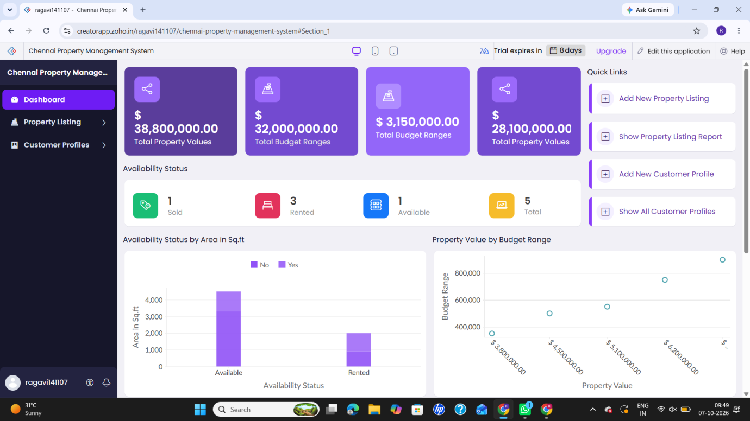

RESULT
Thus, a cloud-based Property Buying and Rental Management System for Chennai was successfully created using Zoho Creator, demonstrating Software as a Service (SaaS). The application allows property details to be entered, stored, viewed and managed online.

EXPERIMENT 3 – Car Booking Reservation System

AIM
To create a simple cloud software application for a Car Booking Reservation System using Zoho Creator to demonstrate Software as a Service (SaaS).

SOFTWARE REQUIRED
- Zoho Creator
- Internet Connection
- Web Browser

PROCEDURE
- Open Zoho Creator and log in to your account.
- Create a new application in Zoho Creator.
- Enter the application name as Car Booking Reservation System.
- Create a new form for entering car booking details.
- Add the Search for Cabs field.
- Add From and To fields for entering the journey locations.
- Add Rental and Out Station options for selecting the booking type.
- Add the Package Type field.
- Add the Hours/Days field for selecting the booking duration.
- Add customer details such as Name, Phone Number and Email.
- Create a report to display the submitted booking details.
- Enter sample booking details and submit the form.
- Verify the submitted details in the report.
- Run the application to demonstrate the Car Booking Reservation System as a SaaS application.

INPUT

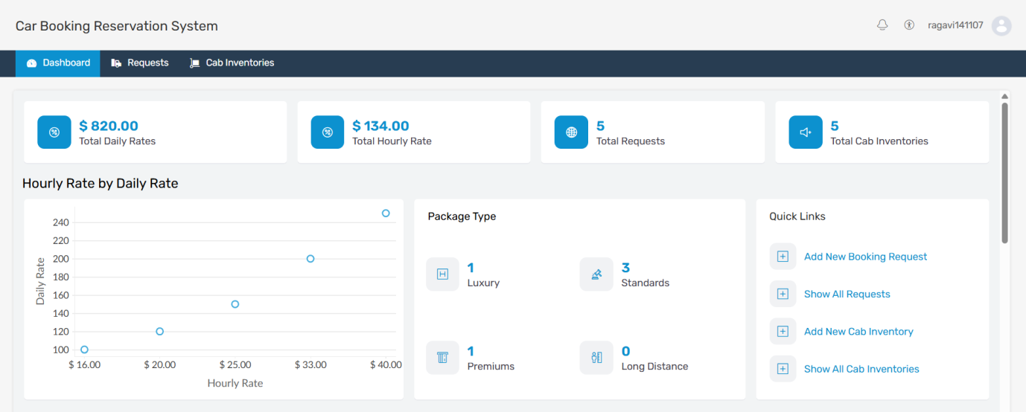

OUTPUT

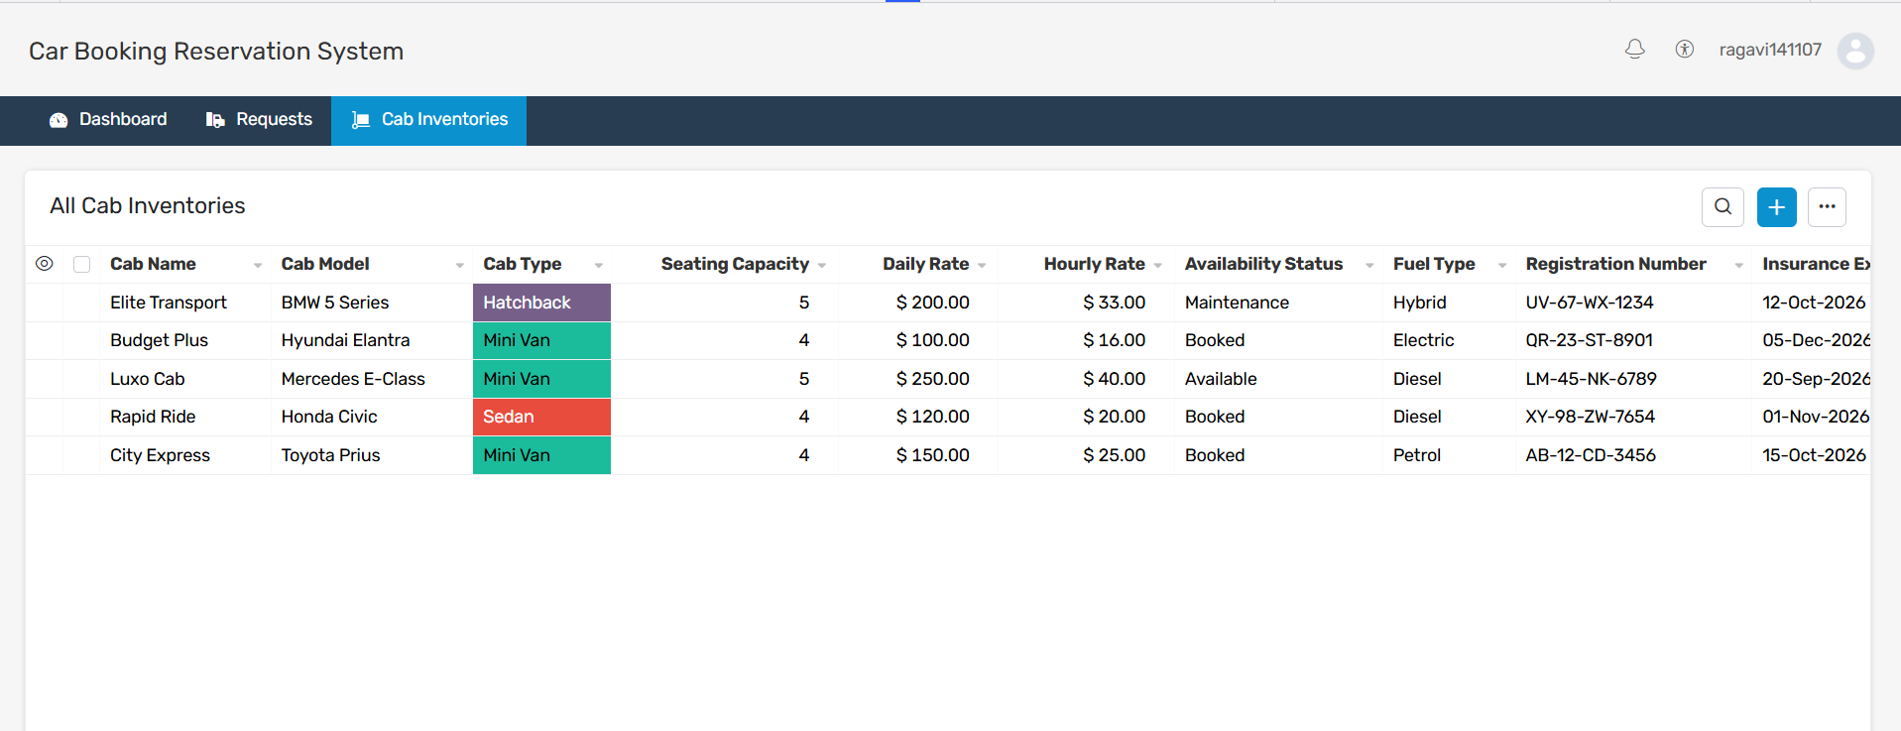

RESULT
Thus, the Car Booking Reservation System was successfully created using Zoho Creator. The application allows users to enter and manage cab booking details through a cloud-based SaaS application.

EXPERIMENT 4 – Library Book Reservation System

AIM
To create a simple cloud software application for a Library Book Reservation System using Zoho Creator to demonstrate Software as a Service (SaaS).

SOFTWARE REQUIRED
- Zoho Creator
- Internet Connection
- Web Browser

PROCEDURE
- Open Zoho Creator and log in to your account.
- Create a new application in Zoho Creator.
- Enter the application name as Library Book Reservation System.
- Create a new form for entering library book details.
- Add the Title of the Book field.
- Add Author and Publication fields.
- Add Year and Edition fields.
- Add the Number of Copies field.
- Add the Rack Number field.
- Add the Status field with options Taken / Returned.
- Create a report to display the entered book details.
- Enter sample book information and submit the form.
- Verify the entered book details in the report.
- Run the application to demonstrate the Library Book Reservation System as a SaaS application.

INPUT

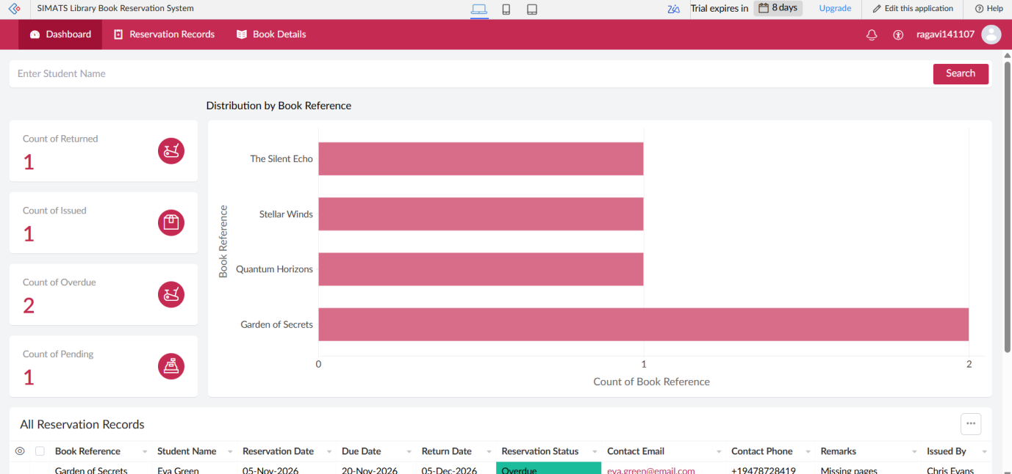

OUTPUT

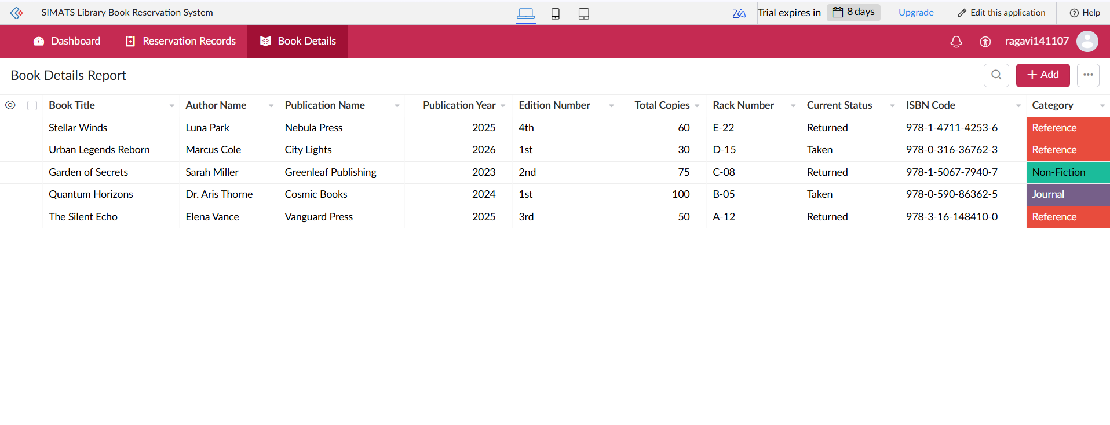

RESULT
Thus, the SIMATS Library Book Reservation System was successfully created using Zoho Creator. The application allows users to enter, store, view and manage library book details through a cloud-based SaaS application.

EXPERIMENT 5 – Mark Sheet Processing System

AIM
To create a simple cloud software application for a Mark Sheet Processing System using Zoho Creator to demonstrate Software as a Service (SaaS).

SOFTWARE REQUIRED
- Zoho Creator
- Internet Connection
- Web Browser

PROCEDURE
- Open Zoho Creator and log in to your account.
- Create a new application.
- Enter the application name as Mark Sheet Processing System.
- Create a new form for entering student marks.
- Add Student Name and Registration Number fields.
- Add fields for Subjects and Marks.
- Add fields for Average and Percentage.
- Add the Rank field.
- Add the Overall Performance field.
- Create a report to display the student mark details.
- Enter sample student details and subject marks.
- Submit the form and verify the entered information.
- Display the processed marks in the report.
- Run the application to demonstrate the Mark Sheet Processing System as a SaaS application.

INPUT

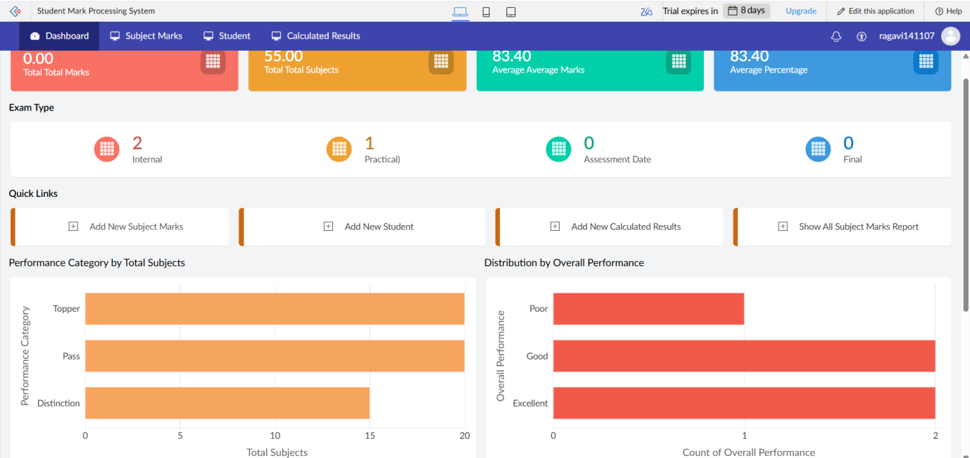

OUTPUT

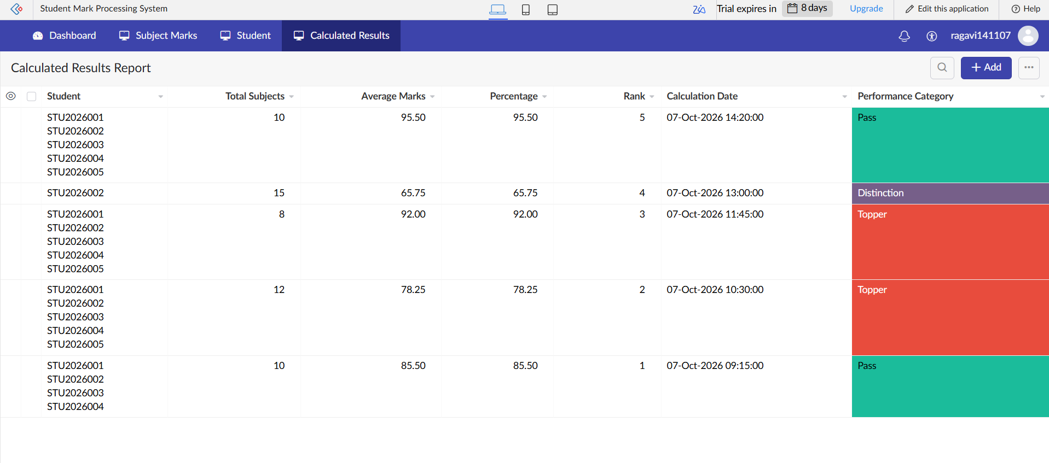

RESULT
Thus, the Mark Sheet Processing System was successfully created using Zoho Creator. The application allows student details and marks to be entered, processed and displayed through a cloud-based SaaS application.

EXPERIMENT 6 – Payroll Processing System

AIM
To create a simple cloud software application for a Payroll Processing System using Zoho Creator to demonstrate Software as a Service (SaaS).

SOFTWARE REQUIRED
- Zoho Creator
- Internet Connection
- Web Browser

PROCEDURE
- Open Zoho Creator and log in to your account.
- Create a new application.
- Enter the application name as Payroll Processing System.
- Create a new form for entering employee payroll details.
- Add the Employee Name field.
- Add Experience in Present Organization and Overall Experience fields.
- Add the Basic Pay field.
- Add fields for HRA, DA and TA.
- Add the Gross Pay and Net Pay fields.
- Create a report to display employee payroll details.
- Enter sample employee salary details and submit the form.
- Verify the entered payroll information in the report.
- Run the application to demonstrate the Payroll Processing System as a SaaS application.

INPUT

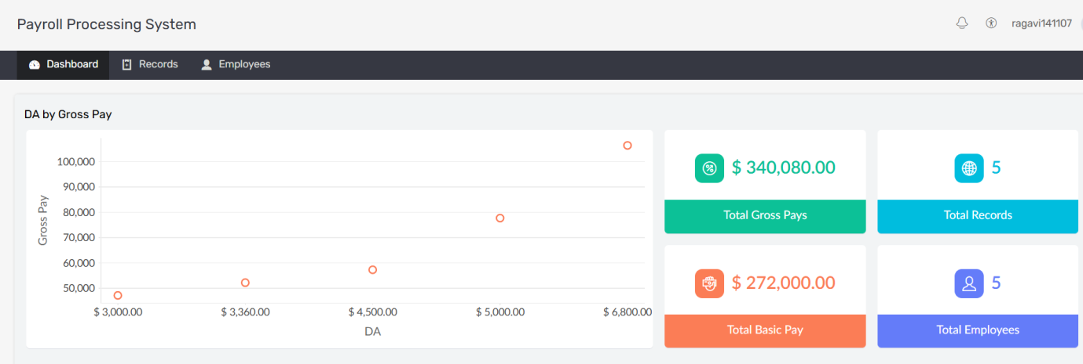

OUTPUT

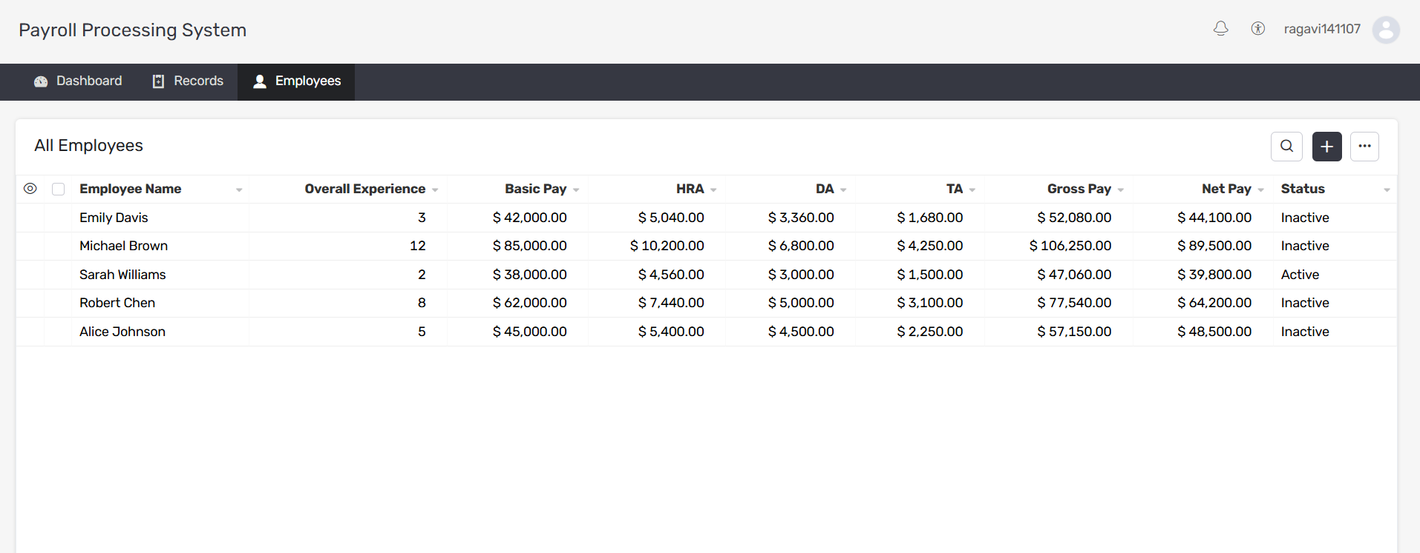

RESULT
Thus, the Payroll Processing System was successfully created using Zoho Creator. The application allows employee payroll details to be entered, processed and displayed through a cloud-based SaaS application.

EXPERIMENT 7 – Students Attendance System

AIM
To create a simple cloud software application for a Students Attendance System using Zoho Creator to demonstrate Software as a Service (SaaS).

SOFTWARE REQUIRED
- Zoho Creator
- Internet Connection
- Web Browser

PROCEDURE
- Open Zoho Creator and log in to your Zoho account.
- Create a new application.
- Enter the application name as Students Attendance System.
- Create a new form for entering student attendance details.
- Add the Student Name and Course fields.
- Add Present and Absent fields.
- Add the Course Attendance field.
- Add the OD Request field.
- Add the Grade field.
- Add the Attendance Percentage field.
- Create a report to display student attendance details.
- Enter sample student attendance details and submit the form.
- Verify the entered information in the report.
- Run the application to demonstrate the Students Attendance System as a SaaS application.

INPUT

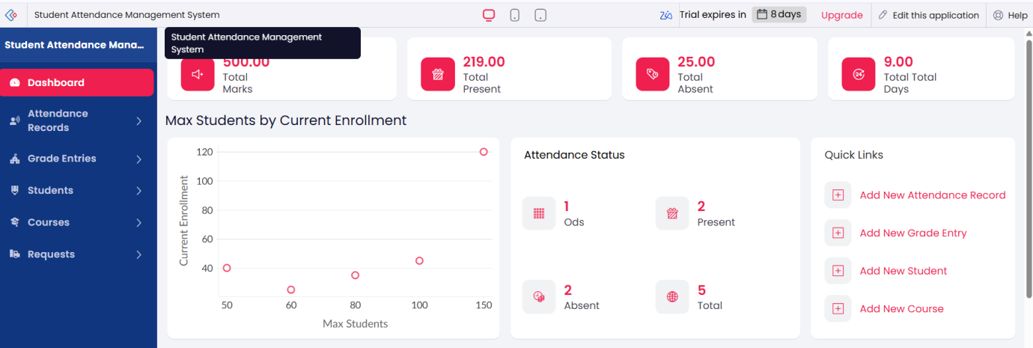

OUTPUT

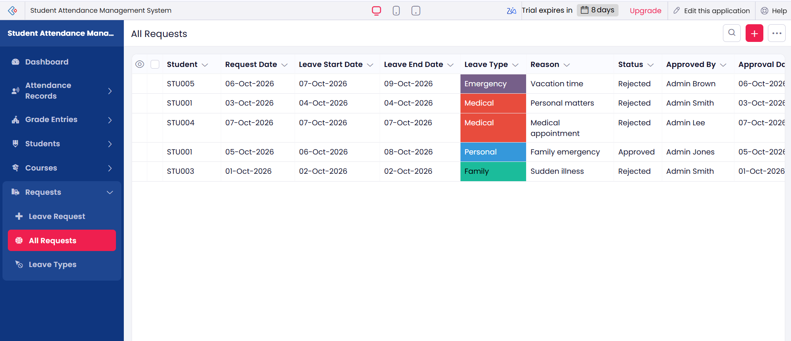

RESULT
Thus, the Students Attendance System was successfully created using Zoho Creator. The application allows student attendance details to be entered, stored, viewed and managed through a cloud-based SaaS application.

EXPERIMENT 8 – Student Counselling System

AIM
To create a simple cloud software application for a Student Counselling System using Zoho Creator to demonstrate Software as a Service (SaaS).

SOFTWARE REQUIRED
- Zoho Creator
- Internet Connection
- Web Browser

PROCEDURE
- Open Zoho Creator and log in to your account.
- Create a new application.
- Enter the application name as Student Counselling System.
- Create a new form for entering student counselling details.
- Add the Student Name and Age fields.
- Add Address and Phone fields.
- Add the Subjects Studied field.
- Add the Year of Passing field.
- Add the Percentage of Marks field.
- Add the Domain Interest field.
- Create a report to display the submitted student details.
- Enter sample student information and submit the form.
- Verify the entered information in the report.
- Run the application to demonstrate the Student Counselling System as a SaaS application.

INPUT

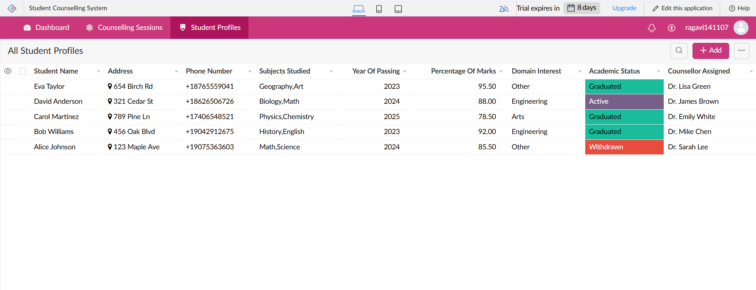

OUTPUT

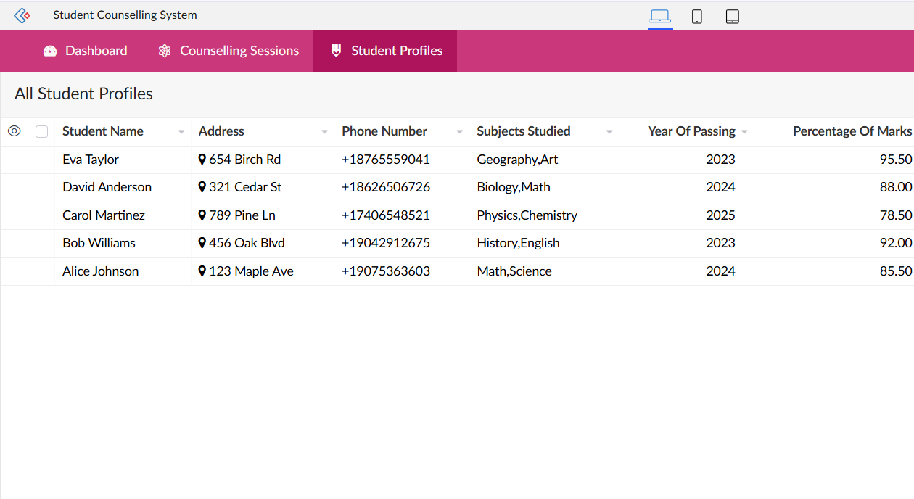

RESULT
Thus, the Student Counselling System was successfully created using Zoho Creator. The application allows student counselling details to be entered, stored, viewed and managed through a cloud-based SaaS application.

EXPERIMENT 9 – Hospital Information System

AIM
To create a simple cloud software application for a Hospital Information System using Zoho Creator to demonstrate Software as a Service (SaaS).

SOFTWARE REQUIRED
- Zoho Creator
- Internet Connection
- Web Browser

PROCEDURE
- Open Zoho Creator and log in to your Zoho account.
- Create a new application.
- Enter the application name as Hospital Information System.
- Create a new form for entering patient information.
- Add the Patient Name and Age fields.
- Add Address, Phone and Email fields.
- Add Attender Name and Attender Phone fields.
- Add the Doctor Name field.
- Add the Diseases field.
- Create a report to display the submitted patient details.
- Enter sample patient information and submit the form.
- Verify the entered patient information in the report.
- Run the application to demonstrate the Hospital Information System as a SaaS application.

INPUT

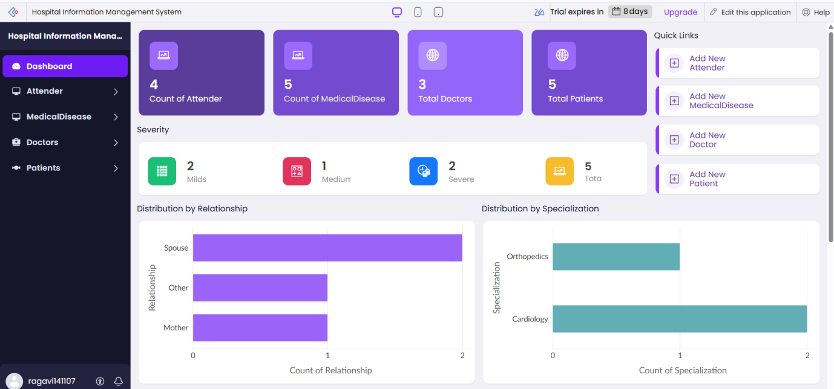

OUTPUT

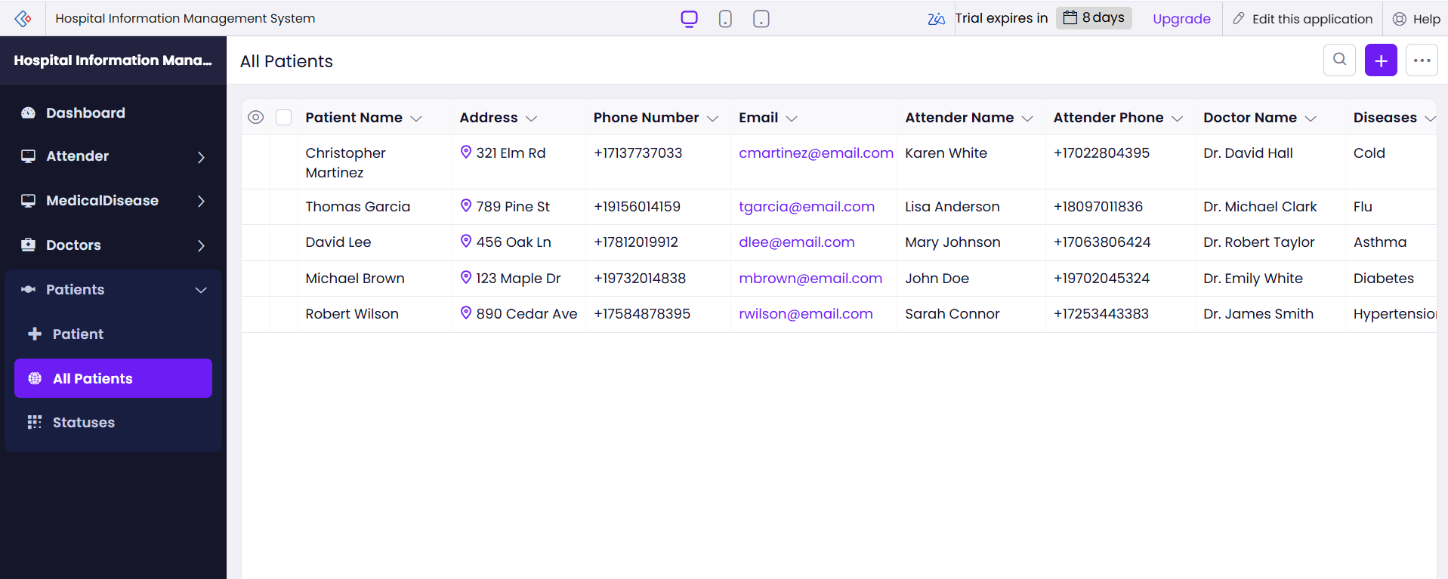

RESULT
Thus, the SIMATS Hospital Information System was successfully created using Zoho Creator. The application allows patient information to be entered, stored, viewed and managed through a cloud-based SaaS application.

EXPERIMENT 10 – Student Information System

AIM
To create a simple cloud software application for Student Information Management using Zoho Creator to demonstrate Software as a Service (SaaS).

SOFTWARE REQUIRED
- Zoho Creator
- Internet Connection
- Web Browser

PROCEDURE
- Open Zoho Creator and log in to your Zoho account.
- Create a new application.
- Enter the application name as Student Information System.
- Create a form for entering student information.
- Add Student Name and Registration Number fields.
- Add Address, Phone and Age fields.
- Add the Courses and Grades fields.
- Create an Attendance Report section.
- Create a Progress Report section.
- Create a Semester Mark Sheet section.
- Create a report to display the student information.
- Enter sample student details and submit the form.
- Verify the entered information in the report.
- Run the application to demonstrate the cloud-based SaaS application.

INPUT

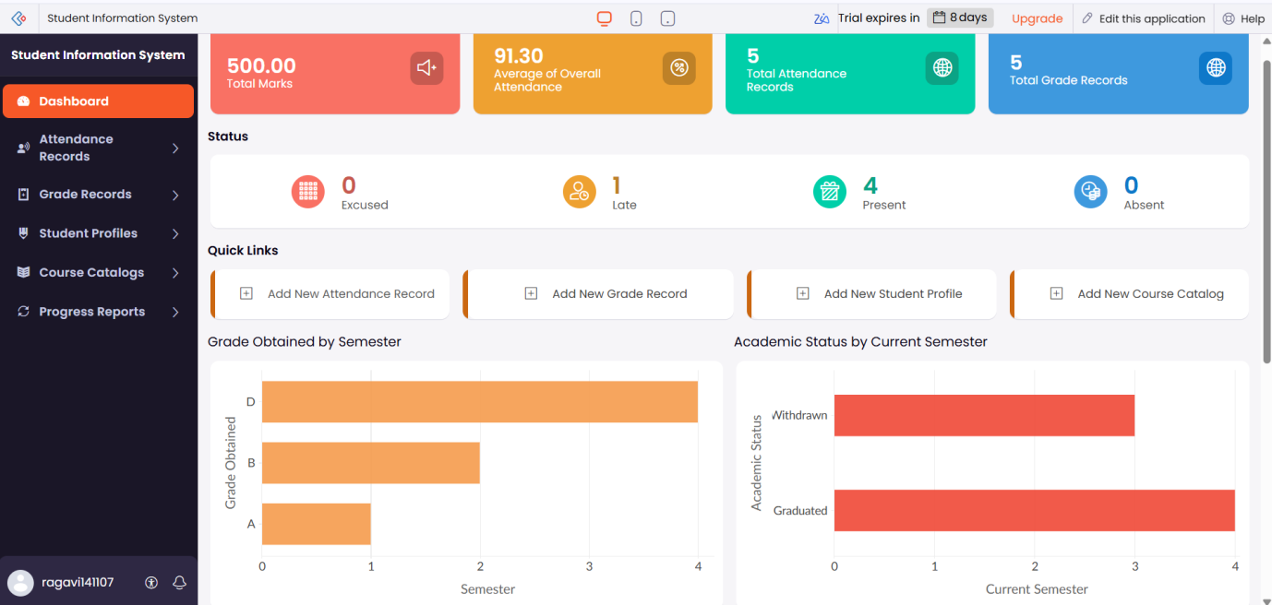

OUTPUT

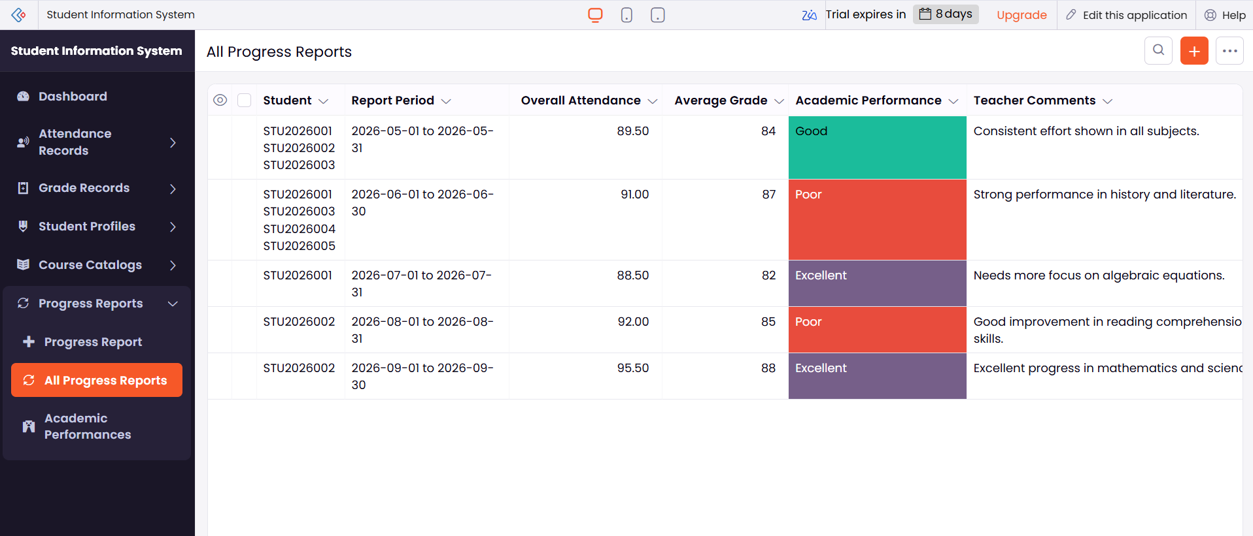

RESULT
Thus, the Student Information System was successfully created using Zoho Creator. The application allows student details, courses, grades, attendance, progress and semester mark sheet information to be entered, stored and displayed through a cloud-based SaaS application.

EXPERIMENT 11 – Online Supermarket System

AIM
To create a simple cloud software application for an Online Supermarket using Zoho Creator to demonstrate Software as a Service (SaaS).

SOFTWARE REQUIRED
- Zoho Creator
- Internet Connection
- Web Browser

PROCEDURE
- Open Zoho Creator and log in to your Zoho account.
- Create a new application.
- Enter the application name as Online Supermarket System.
- Create a new customer/order form.
- Add Customer Name, Address, Phone and Email fields.
- Add the Items field to enter the products required.
- Add the Quantity field.
- Create an Item Classification field to classify the products.
- Create a report to display the submitted customer and order details.
- Enter sample customer and item details.
- Submit the form and verify the information in the report.
- Run the application to demonstrate the Online Supermarket System as a SaaS application.

INPUT

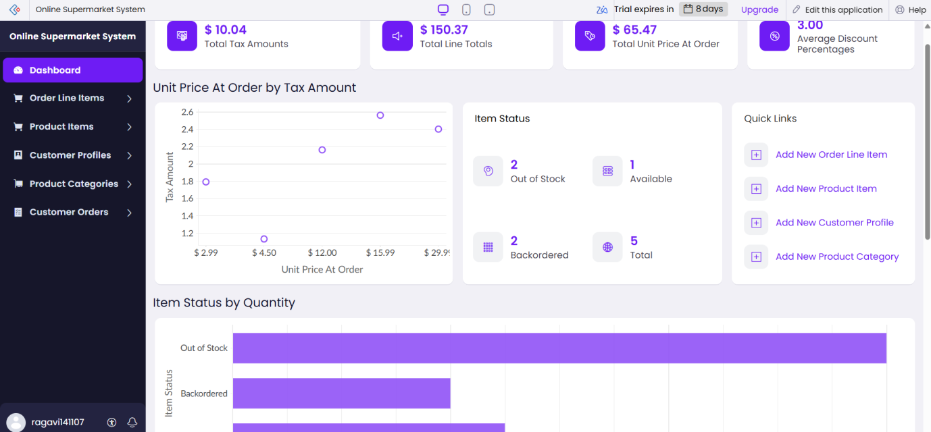

OUTPUT

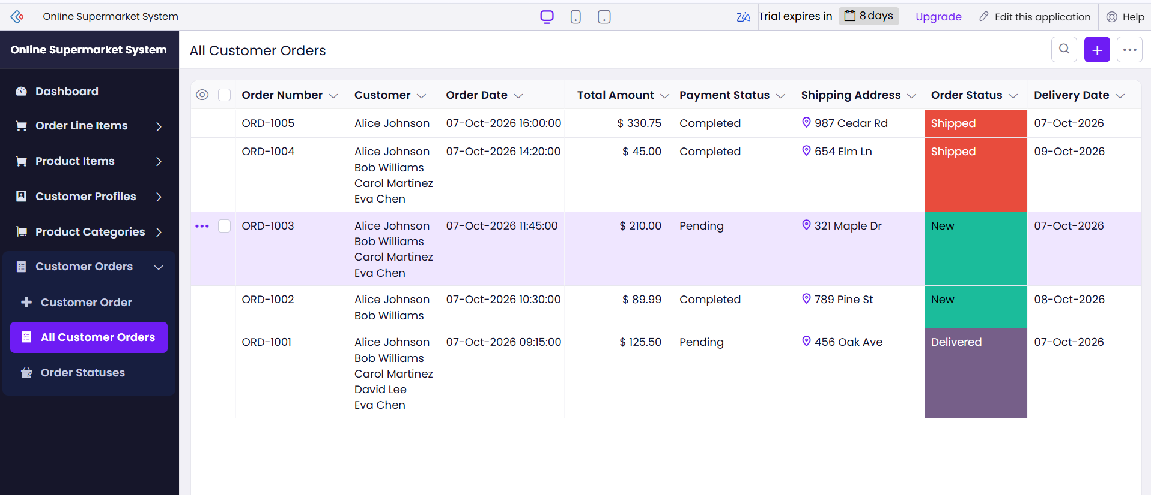

RESULT
Thus, the Online Supermarket System was successfully created using Zoho Creator. The application allows customer details, items, quantity and item classification to be entered, stored and displayed through a cloud-based SaaS application.

